Kettering Car Consumers

Student Names

Kettering University

Johanna Brown

Comm 301

Author Note

This mini-thesis is submitted as fulfillment of the requirements of Kettering University’s Comm 301 course in order to obtain a passing grade in the class. The conclusions and opinions expressed in this thesis are from myself and do not necessarily represent the position of Kettering University or anyone else affiliated with this culminating undergraduate experience.

Although this thesis represents the compilation of our own efforts, we would like to acknowledge and extend our sincere gratitude to the following individuals for their valuable time and assistance, without whom the completion of this thesis would not have been possible: Johanna Brown, Kettering University Communications Professor for her help in editing and revising the writing portion of this project.

**Abstract**

Kettering University states that a student must have their own vehicle for transportation to their co-op. A study was conducted using sources such as Kelly Blue Book to help derive what the most practical new car would be for college students to purchase. It was found that the 2018-19 Subaru Impreza sedan is the best car for students to purchase, with the Mazda 3, Mazda CX-3, and Hyundai Kona also holding top rankings. This study is beneficial to not only students who are unsure of where to start looking, but to the university as it holds them in a better light when looking after their students. The study was limited to cars that were not soon to be discontinued, and the used car market was not considered.

*Keywords*: Kettering University, student, vehicle, Kelly Blue Book, Subaru, Mazda, Hyundai, ranking, discontinued, used, car

Table of Contents

Abstract 2

Introduction 3

Conclusions and Recommendations 5

Methods 8

Results and Discussion 10

References 12

Appendix 14

List of Illustrations

Figure 1: Chevrolet Trax 7

Figure 2: Ford EcoSport 7

Figure 3: Subaru Impreza 5-Door 7

Table 1: Original Line-up 8

Table 2: Final Four 8

Figure 4: Honda Civic 10

Figure 5: Kia Soul 10

Figure 6: Honda Fit 10

Figure 7: Subaru Impreza 4-Door 11

Figure 8: Mazda 3 4-Door 11

Figure 9: Mazda CX-3 11

Figure 10: Hyundai Kona 11

Kettering Car Consumers

The purpose of this thesis is to determine which car is the best choice for incoming Kettering Students. The problem that the team is trying to solve is that students that are new to Kettering University may need to purchase a vehicle, but may not have the experience or knowledge to know how to start their search. The objective of this project is to narrow down four cars from a list of ten and compare them to find the best one suited to an incoming freshman. The results of this research will help new students find a car that is suitable for them in both use and cost.

**Background**

Kettering University states that students must purchase or have their own vehicle at Kettering to transport themselves to and from their co-op positions. However, for many college students, they have never purchased a car before, and this is the first big purchase they have made. It is easy to be overwhelmed by the car market as there are a mass quantity of vehicles to choose from, all with their own options lists and prices. Since Kettering is requiring students to purchase a vehicle, it would be helpful if the school was able to give out useful information to students on what kind of vehicle would be useful during their academic and professional career, while attending the university.

The objective of this project would be to narrow down the specs and options on a car that would be the most optimal for a student to have, and a short list of the top five or ten most practical vehicles for a college student to own. For the students, the outcome of this project would be that the guesswork would be taken out of the car buying process, as they would have a list of things to look for in a future vehicle or a list of preselected vehicles that they can find on lots and go test drive. For the university, the outcome would be that the school would look more prepared if they were able to offer useful information for students to use when car shopping. This would also help the university seem as though they care more about the large financial commitment they are placing students in, on top of paying for the expenses of attending the university.

Kelly Blue Book was used to help create a short list of cars to compare, and then the top three were used in a survey. This survey was sent out to college students, containing questions about what they consider when purchasing a car, and at the end had them pick between the top three cars the team got from Kelly Blue Book.

Upon the completion of the survey, another study was conducted with a new, larger sample of criteria that was found from the preferences of new students. Using Incremental Analysis and a gradient multiplier scale from 1.1-1.3, the cars were ranked and the scores multiplied until a final set of vehicles was formed. The process was repeated with the four final vehicles to determine the top four vehicles for Kettering students.

**Conclusions and Recommendations**

After the conduction of the survey and evaluating the new car market with the new criteria, the top four cars were selected for Kettering students to purchase with a definite best pick, second, third, and fourth place. It was found that the 2019 Subaru Impreza is the best vehicle for Kettering students because of its combination of valued price of $18,595, fuel efficiency of 33 mpg combined, and superior safety over the competition rating 5-stars in all categories plus standard AWD. The Subaru Impreza also takes first in another, non-competitive category listed in the survey; Technology and features, while also placing in KBB’s Most Awarded Vehicles for 2018 and placing in KBB’s 2018 Top 10 Coolest Cars Under $20,000. In second place, the Mazda 3 took hold with a price of $18,095, fuel efficiency of 32.5 mpg combined, and a 5-star crash safety rating. In third, the Mazda CX-3, the CUV brother of the Mazda 3 sedan with 31.5 mpg combined, a starting price of $20,390, and a 5-star crash safety rating. And in fourth place, the Hyundai Kona rounded out the competition with 30 mpg combined, and a 5-star crash safety rating. All crash safety ratings are from the Insurance Institute of Highway Safety, IIHS. Out of the four vehicles in the last round of analysis, the Subaru was second in cost, being only a couple of hundred dollars more than the Mazda 3, but had the best fuel efficiency and IIHS crash safety ratings of the group, pushing the Subaru into the top spot.

For students that responded to the survey with specific criteria that did not match with the majority of the responses, other vehicles have been included for those with niche preferences. For the students who only buy American domestic vehicles, it is recommended that they purchase a Chevrolet Trax. The American domestic market has other options currently available for purchase that are cheaper than the listed vehicles, however, they will be discontinued before the end of the year, or end of the calendar year of 2020 with no replacement vehicles taking their place as the domestic Original Equipment Manufacturers, OMEs shift to larger vehicle classes such as CUV’s and SUV’s. To keep the analysis relevant, those vehicles have not been included as options. The Trax was selected over its only other domestic rival due to the same factors for the rest of the analysis. Although the Trax has a slightly higher starting price of $21,300 vs the EcoSports $19,995, the Trax has superior fuel efficiency and crash safety rating, offsetting the increased price point. The EcoSport does not even achieve 30 mpg on the highway, whereas the Trax achieves 31 mpg highway. They both have the same combined rating. For safety, the Trax earns 5-star rating overall with 5 star ratings in 3 out of 4 categories, with an increased vehicle warranty and On-Star crash communication services. The EcoSport garnered an overall 4-star rating with 5-stars in 2 out of 4 categories, with one category going as low as 3.

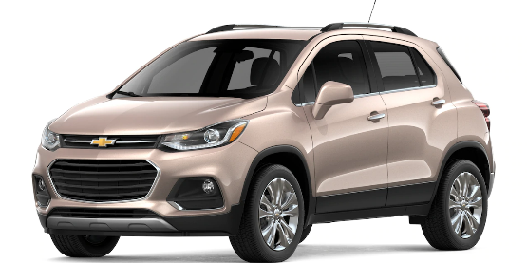 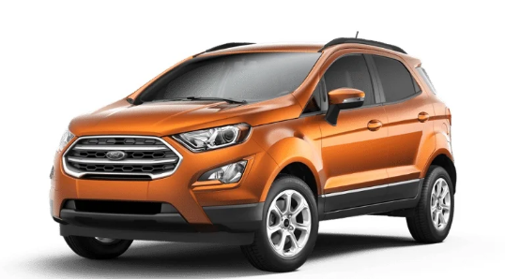

Fig. 1 Chevrolet Trax Fig. 2 Ford EcoSport

Students also responded that they needed vehicles other than sedans due to the need for cargo space that that class of vehicle does not supply. There are the third and fourth place holders in the final outcomes that are fine options, the Mazda CX-3 and Hyundai Kona, but if students wanted the most cargo space, all they would have to do is look at the overall winner once again. The Subaru Impreza comes in sedan and wagon form. For a $500 increase MSRP and a 1 MPG hit on overall highway mileage from 38 to 37 mpg. The Impreza has a total capacity of 55.2 cubic feet of cargo space. The next closes in the study is the Chevrolet Trax with 48.4 cubic feet, with 6.8 fewer cubic feet of space, making the Subaru superior.

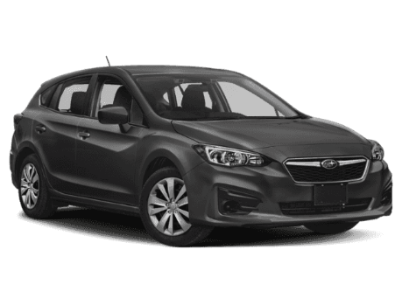

Fig. 3 Subaru Impreza 5-Door

**Methods**

The method of research chosen by the team was a survey of Kettering and Non-Kettering University students for a total of nine universities from New York, Michigan, Florida, and Ontario, Canada. This was determined to be the best way to get an idea of what college students are looking for and what they are most concerned about when they are searching for a new vehicle. The survey was created using Google Forms, and the three vehicles the students chose between were based on results from Kelly Blue Book’s “10 Best Back-to-School Cars 2018” article for college students.  
 This survey consisted of questions such as if the user would buying or leasing a vehicle, their preferences of what they are looking for in a new vehicle, and what vehicle of the three recommended by Kelly Blue Book would they be most inclined to purchase if they were the only options.

Using the data that was garnered from the student survey, a new, larger group of ten vehicles were selected to compare that fit the recommended desires of students. It is assumed that these cars would be bought brand new at a constant price, in order to avoid the variability in price of used cars. Vehicles that are on sale that will be discontinued in the coming months or year were disregarded from the selection process. Using Incremental Analysis, the vehicles were broken into three groups of three, three, and four, with a multiplier of 1.1 for cost, 1.2 for MPG, and 1.3 for safety, in the order of importance to the students. The cars in the groups were ranked using Kelly Blue Book’s side-by-side comparison tool from 1 to 3 or 1 to 4 due to group sizing. The vehicles with the lowest scores, lower than a score of six, were chosen to continue to the final round. To achieve a score of six or lower, a vehicle must not have had placed second more than twice, or third more than once. All other scores must be first place. The four cars that met the criteria moved onto the final round and were scored the same way, with this round having a ranking from 1 to 4. The lowest score, in the end, was the vehicle recommended for student purchase.

Table 1

*Original Line-up*

|  |  |  |  |  |
| --- | --- | --- | --- | --- |
| Car | Cost | MPG | Safety | Total |
| Subaru Impreza | (1.1)*1 | (1.2)*3 | (1.3)*1 | 6 |
| Honda Civic | (1.1)*2 | (1.2)*2 | (1.3)*2 | 7.2 |
| Hyundai Elantra | (1.1)*3 | (1.2)*1 | (1.3)*3 | 8.4 |
| Hyundai Ionic | (1.1)*4 | (1.2)*1 | (1.3)*2 | 8.2 |
| VW Jetta | (1.1)*2 | (1.2)*2 | (1.3)*3 | 8.5 |
| Toyota Corolla | (1.1)*3 | (1.2)*2 | (1.3)*3 | 9.6 |
| Mazda 3 | (1.1)*1 | (1.2)*3 | (1.3)*1 | 6 |
| Mazda CX-3 | (1.1)*2 | (1.2)*1 | (1.3)*1 | 4.7 |
| Toyota C-HR | (1.1)*3 | (1.2)*3 | (1.3)*1 | 8.2 |
| Hyundai Kona | (1.1)*1 | (1.2)*2 | (1.3)*2 | 5.9 |

*Note*: Chart comparing the original ten cars

Table 2

*Final Four*

|  |  |  |  |  |
| --- | --- | --- | --- | --- |
| Car | Cost | MPG | Safety | Total |
| Subaru Impreza | (1.1)*2 | (1.2)*1 | (1.3)*1 | 4.7 |
| Mazda 3 | (1.1)*1 | (1.2)*2 | (1.3)*2 | 6.1 |
| Mazda CX-3 | (1.1)*4 | (1.2)*3 | (1.3)*2 | 10.6 |
| Hyundai Kona | (1.1)*3 | (1.2)*4 | (1.3)*3 | 12 |

*Note*: Chart comparing the final four cars

**Results and Discussion**

After 52 responses, the Honda Civic is at 71.2%, the Kia Soul has 17.3%, and the Honda Fit has 11.5%. As for what students are most concerned about, the most important factor is the cost of the vehicle, the second most important is gas mileage, and the third is safety. The team has also received a lot of feedback from students, saying that they did not like the car options and that they would never actually buy them. The exact number of complaints was half of the recipients with 26 out of the 52 stating that the vehicle selection within the survey were subpar to their preferences, and that they would never consider any of the given vehicles to purchase. The team is taking these concerns into consideration and recommends other vehicles to pander to their needs.

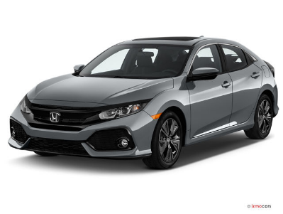 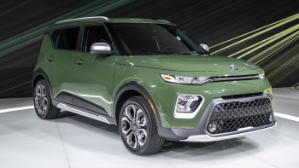 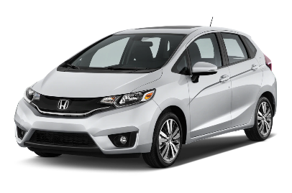

Fig. 4 Honda Civic Fig. 5 Kia Soul Fig. 6 Honda Fit

Using Incremental Analysis, the top four cars based on cost, gas mileage, and safety were calculated. Coming in first was the Subaru Impreza with a score of 4.7 points. Next was the Mazda 3 with a score of 6.1 points. The Mazda CX-3 came in third with a total of 10.6, and finally the Hyundai Kona came in fourth with a score of 12. Based on these results, the car that best meets the three initial requirements would be the Subaru Impala, as it placed 2nd in cost and 1st in gas mileage and safety. However, as the number one concern students had was the cost of the vehicle, it could be argued that the Mazda 3 is also a good choice, as it placed 1st in cost and 2nd in gas mileage and safety. There were several limitations to this study, the most pressing being that the team could not have the cars available for the students to test drive. As a result, the team had to rely on data from the survey and the students’ prior experience and/or opinions.

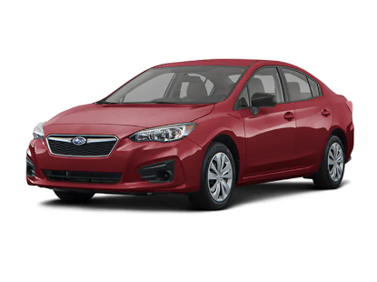 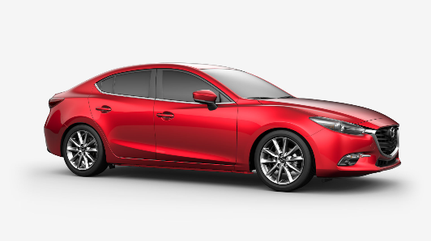

Fig. 7 Subaru Impreza 4-Door Fig. 8 Mazda 3 4-Door

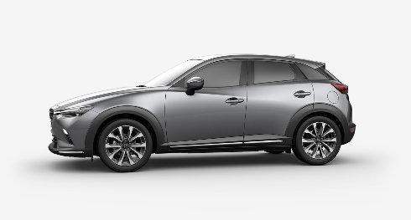 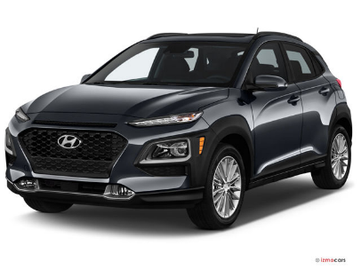

Fig. 9 Mazda CX-3 Fig. 10 Hyundai Kona

**References**

“10 Best Back-to-School Cars 2018 | Kelley Blue Book.” Kbb.com, Kelley Blue Book, 1 Aug. 2018, 1:09 pm, [www.kbb.com/car-reviews-and-news/top-10/best-back-to-school-cars-2018/2100005631/?slide=10](http://www.kbb.com/car-reviews-and-news/top-10/best-back-to-school-cars-2018/2100005631/?slide=10).

Kelly Blue Book (KBB) provides wonderful research tools and premade lists for people to choose from for a plethora of customers and their needs. Specifically, the list that was used in the research was “10 Best Back-To-School Cars of 2018”. This list was used as a basis to choose cars that would fit students’ needs.

“Chevrolet Cars, Trucks, SUVs, Crossovers and Vans.” *Chevrolet Cars, Trucks, SUVs, Crossovers and Vans*, [www.chevrolet.com/](http://www.chevrolet.com/).

Chevrolet is the automotive original equipment manufacturer that produces the included vehicle, the Chevy Trax. Some details about the vehicle were taken from the website such as the cargo space and some technical features that the vehicle has included in its base model.

“Ford – New Cars, Trucks, SUVs, Crossovers & Hybrids | Vehicles Built Just for You‎.” *Ford Motor Companies*, [www.ford.com/](http://www.ford.com/).

Ford is the automotive original equipment manufacturer that produces the included vehicle, the Ford EcoSport. Some details about the vehicle were taken from the website such as the fuel economy, cargo space, price and technical features that are include within the base model.

*IIHS Crash Test Ratings, News, & More*, m.iihs.org/mobile.

IIHS is the Insurance Institute for Highway Safety and regularly puts cars through a multitude of driver handling and vehicle crash safety tests with every significant redesign of a vehicle that would garner a possible change in the vehicles scores. For this project, the crash safety scores of the vehicles were gathered and culminated to compare and contrast which vehicles were rated the safest for consumers.

**Appendix**

College Data Pool:

* Kettering University, MI
* Western Michigan University, MI
* Fingerlakes Community College, NY
* Keuka College, NY
* St. Bonaventure University, NY
* Stoneybrook University, NY
* Florida Southwestern State, FL
* University of Florida, FL
* Laurentian University, Canada

Survey Results:

